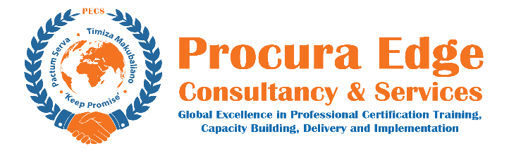

WHO WE ARE
Our focus is supply chain strategy and the people who run it.
We help organizations in three ways: we train teams and individuals, source and place supply chain talent, and lead or support supply chain transformation projects, either running them ourselves or working alongside your team. Together, we bring decades of hands-on experience, and we're genuinely committed to this work.

OUR HISTORY
Procura Edge Consultancy & Services (PECS) was established in 2020 and has grown into a leading Kenya-based provider of supply chain training, recruitment, and advisory services for organizations of every size. Our people have worked across both large blue-chip firms and smaller enterprises, spanning sectors such as food retail, manufacturing, wholesale, construction, automotive, public administration, healthcare, education, and life sciences technology, among others. At PECS, we shape solutions around each client's needs, supplying the skills, resource development, and strategic direction organizations need to perform well. Whatever the requirement training for a team or an individual, recruiting a single specialist or a full department, or advisory support to design or deliver a supply chain strategy we're set up to help whenever it's needed.

CONSULTANCY
The experience your customers have should mirror your strategy and value proposition, and it should do so at a cost your business can sustain. Your supply chain is the mechanism that turns that strategy into reality for the customer. When customers aren't receiving what they expect, when they expect it, at the price your business plan requires, that's where our consultancy work comes in.

OPTIMISING YOUR SUPPLY CHAIN
A supply chain isn't just a process; it's the underlying engine that produces, delivers, and presents what you sell. At PECS, we focus on building supply chains that perform strongly and give clients a genuine competitive edge. Our advisory work helps organizations procure and operate in ways that are strategic, ethical, efficient, and sustainable. Whether the issue is strategic, such as aligning the supply chain with overall business objectives, or more tactical, like managing supplier performance or cutting logistics costs, PECS is positioned to help. We use a proprietary supply chain framework with clients to help them locate exactly where their pain points and opportunities sit. Beyond consultancy, PECS also runs a broad course portfolio for procurement, supply chain, and project management professionals, alongside recognised local and international certifications, whether that means working toward CIPS qualifications or building project management expertise. In short, PECS exists to give organizations of any size the supply chain expertise, resources, and skills they need, on demand.

TRAINING AND CERTIFICATION

CIPS Global Professional Certification Qualifications
The Chartered Institute of Procurement and Supply (CIPS) works to raise and maintain professional standards, competence, and integrity across the procurement and supply chain field. PECS holds approved status as a CIPS Study and CBE Examinations Centre. We welcome applications from anyone interested in pursuing globally recognised procurement and supply chain qualifications, including:
- CIPS Level 2 Certificate in Procurement and Supply
- CIPS Level 3 Advanced Certificate in Procurement and Supply
- CIPS Level 4 Diploma in Procurement and Supply
- CIPS Level 5 Advanced Diploma in Procurement and Supply
- CIPS Level 6 Professional Diploma in Procurement and Supply
Our CIPS programs stay current with the syllabus and are led by CIPS-approved tutors who are themselves practising supply chain professionals, trainers, examiners, and holders of MCIPS and FCIPS status, with substantial teaching experience. PECS has been putting the CIPS vision into practice by supporting individuals, organizations, and the wider profession with tuition designed to give learners the knowledge and practical skills to get the most from their procurement careers. Programs are competitively priced and can be delivered online or in person for clients outside Kenya. Study with us from wherever you are, and build toward strong results with our support.
For more information, email procuraedge@info.ke to register.

CIPS CURRICULUM DELIVERY METHODOLOGY

Course Design & Development Methodology
Our tutors /Instructors build every course on a foundation of pre-course research and early input from key stakeholders, so the result is relevant and genuinely owned by everyone involved.
The process starts with a training needs analysis looking closely at performance gaps, differences among learners, the role technology plays, and the wider organizational context.
From there, the tutor designs the course structure, weighing organizational priorities, existing processes and procedures, budget, available resources, and the nature of what's being taught.
Training objectives are then set based on that analysis and design work. Some goals are better served through job aids, on-the-job experience, or equipment changes rather than classroom teaching, so each identified need is examined further to determine the best training approach.
Custom training materials and aids built around practical examples, questions, and individual or group exercises are then delivered, either online via webinar or in person at a client-chosen location. Materials are developed against the CIPS curriculum with an emphasis on knowledge retention and workplace application.
To build trainee confidence and competence, several approaches are combined in how materials are designed and delivered:
# | Approach | Comments
1 | Variety | A mix of training methods is used, and the pace and style are varied to keep learning effective.
2 | Feedback | Oral and written checks are built in to reinforce what's been covered and build trainees' confidence.
3 | Small doses | Content is paced deliberately, since adult learners tend to disengage if given too much material at once.
4 | Interest | Materials are kept concise and focused, and group discussion is used to keep trainees engaged.
5 | Repetition | Short recaps precede new material, so key points are reinforced before the group moves on.
6 | Participation | Every trainee gets an opportunity to contribute, since each person's input has value.

i. Delivery Strategy
Training design and delivery draw on practical adult-learning methods. Experience shows that hands-on modules improve how much trainees retain. A combination of the following methods is typically used:
Checklists: Trainees /Apprentices work through a series of questions, answering Yes/No or Agree/Disagree, either individually or in groups depending on the learning objective.
Readings: Trainees review short materials on a given topic, written at a level everyone can follow, designed to prompt critical thinking about current or ideal procurement practice.
Exercises: Short, targeted exercises done individually or in small groups help trainees apply concepts and connect them to real work.
Case studies: An interactive method that keeps trainees engaged; combined with group discussion, it lets more experienced trainees pass on knowledge to the rest of the group.
Brainstorming: Used in plenary sessions to work through areas of confusion via open Q&A, weighing the pros and cons of each option before settling on the best one.
Role-play: Trainees may be asked to summarise a session or make a short presentation on a topic, building presentation skills alongside subject knowledge.
Presentations: Materials built as slide decks and Word documents support instructor-led sessions delivered engagingly, so trainees can compare best practice with what happens back at their own organizations.
Storytelling: Trainers share real examples of good and bad practice, and trainees are invited to contribute their own local examples to enrich the discussion.

ii. Training Plan
The training plan sets out how a program will run, covering location, duration, and number of trainees, along with a time estimate and a list of the materials and methods needed.

iii. Training Content
Course modules are designed around the target audience, moving from simple to more complex material so learners at different levels can follow along.

iv. Tutor Team
Clients have access to a team of experienced, qualified tutors, several holding FCIPS or MCIPS status, and some with prior experience as CIPS markers.

v. Ongoing Student Support
Unlimited support is available to students wherever they're based. Through blended part-time and online learning, students get access to online materials, and those struggling or underperforming in assessments can arrange one-to-one tutor support via webinar.

vi. Bespoke Courses
Custom procurement courses on specific topics of interest are also delivered, ranging from one to five days, with continuous assessment tracked on a scorecard of particular relevance to government institutions. A sample appears below.

vii. Sample Class Scorecard — RwandAir
CIPS L4M3 — Module Scorecard
Coursework for the March 2023 – July 2023 CIPS Open Cohort
CIPS No. | Student Name | Class Attendance % | LO1-CAT | LO2-CAT | LO3-CAT | % Mock | % Grade | Remark
1
2
3
4
5

For example, CIPS specifies a requirement of 25 for OR – 6 Credit Modules and a requirement of 50 for the CR-12 guided learning hours per unit; our cohort achieved each unit's learning outcomes in just 10 guided learning hours.

Further Teaching Methodology
Our methodology is designed to help every student attending at least 60% of scheduled classes meet or exceed the CIPS global pass rate, while growing the number of professionally qualified staff working in public financial management roles across government.
“The tutor's approach stays flexible and consultative throughout the engagement, with continuous refinements made along the way to deliver a standard of quality that stands apart.”
The following section sets out our approach to CIPS tuition. Since CIPS revised its syllabus in 2018, our delivery has been adapted to reflect those changes.

PROFESSIONAL SUPPLY CHAIN MANAGEMENT QUALIFICATIONS
We aim to deliver a curriculum that is world-class, engaging, and closely aligned with what organizations, procurement professionals, and those aspiring to enter the field actually need today. We're proud to maintain a pass rate above 95%.
Note: PECS provides training only; students must register separately with the Chartered Institute of Procurement & Supply (CIPS) or other Professional awarding bodies that confer the Certification qualifications.
On request, an employer such as RwandAir may pay CIPS fees on a delegate's behalf; where that arrangement is used, a 5% facilitation fee applies to the amount transmitted.

CIPS — Global Qualifications
CIPS qualifications set the benchmark for professional education in procurement and supply worldwide. CIPS supports its members' professional growth and helps the wider business community raise standards in procurement. Its Diploma in Purchasing and Supply is a high-level qualification, accredited by the UK's Office for Qualifications and Examinations Regulation (Ofqual) and listed on the Register of Regulated Qualifications (register.ofqual.gov.uk).
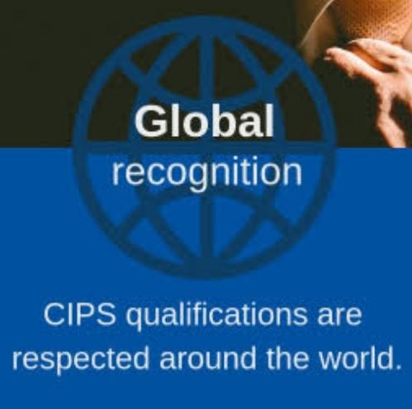
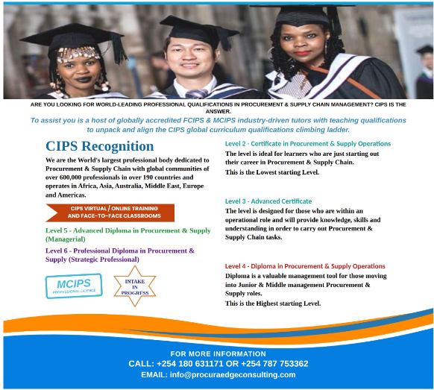
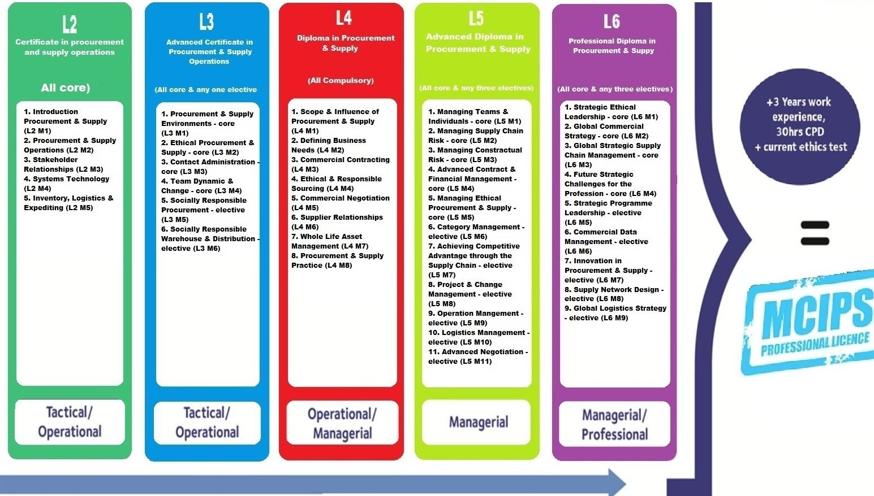
Support is available for each of the following qualification levels ahead of upcoming CIPS exams:
CIPS Level 2 Certificate in Procurement and Supply Operations
The first of CIPS' three entry-level qualifications. * Suited to those starting in procurement and supply, those for whom it's part of a broader role, or anyone with limited business background looking to move into the field. It's also useful for managers in other disciplines, business leaders, or entrepreneurs who want to understand how procurement works and how it affects business performance. This level covers five core units.
*Levels refer to the UK Regulated Qualifications Framework; other regulators may classify levels differently.
CIPS Level 3 Advanced Certificate in Procurement and Supply Operations
The second entry-level qualification, preparing learners for a procurement and supply career and for progression to the Level 4 Diploma. It comprises four core modules plus one elective.
CIPS Level 4 Diploma in Procurement and Supply
The third entry-level qualification, made up of eight core modules built around the operational and managerial tiers of the CIPS Global Standard. Candidates begin with L4M1 (Scope and Influence of Procurement and Supply) and finish with L4M8 (Procurement and Supply in Practice); the remaining modules can be taken in any order.
CIPS Level 5 Advanced Diploma in Procurement and Supply
Built around the managerial and professional tiers of the CIPS Global Standard, this level helps build confidence, strengthen the procurement function's output, and support organizational goals. Candidates complete five core modules plus three electives.
CIPS Level 6 Professional Diploma in Procurement and Supply
The route to MCIPS status, building on the knowledge and skills developed at Level 5. Candidates complete four core modules plus three electives.

Financial Proposal
CIPS Level 4 Diploma Fee — Tuition Charges – East African Community Citizens excluding Kenya
Item | Cost per unit (USD) | Participants | Line total (USD)
Tuition — Core Route, Tutor + study materials | 135 | 2 | 270.00
Tuition — Optional Route, Tutor + study materials | 125 | 6 | 750.00
Administration fee | 50 | 1 | 50
Subtotal (excl. applicable taxes) |  |  | 1,070.00

CIPS Component Charges
Item | Cost per unit (GBP) | Participants | Line total (GBP)
CIPS membership fee, paid directly to CIPS by the prospective member | 109 | 1 | 109.00
CR exam fee, paid directly to CIPS by the candidate | 96 | 2 | 192.00
OR exam fee, paid directly to CIPS by the candidate | 68 | 6 | 408.00
Subtotal |  |  | 709.00

The quoted costs apply to Level 4 (Diploma), as Level 5 (Associate) and Level 6 (Professional) are unstated; the above are exclusive of any fee changes CIPS anticipates introducing over the following year (s).

Payment Details
Account name: Procura Edge Consultancy & Services
P.O. Box 17843 – 00100, Nairobi
Account number: 1162248 (KES)
Bank: Co-operative Bank of Kenya
SWIFT code: KCOOKENA
Branch code: 11045 | Bank code: 11000
Branch: Kimathi Street, CBD Nairobi

1a. Clients
A selection of client and partner logos:
 | 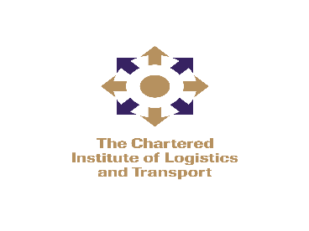 | 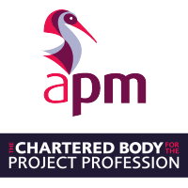 | 

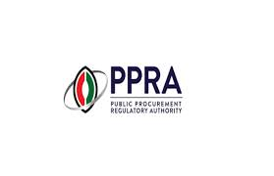 |  |  |  |  | 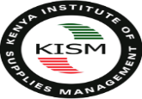 |  | 
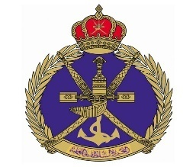 | 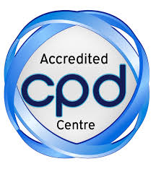 |  |  |  |  | 
 |  |  |  | 

1b. Some Regional and International Clients
Our training programs have drawn participants from major organizations including:
# | Organization | # | Organization
1 | RwandAir | 2 | Kenya School of Government
3 | Safaricom Ltd | 4 | German Technical Cooperation (GIZ)
5 | Rwanda Environment Management Authority | 6 | Zabeel International Institute
7 | Kivu-Watt, Rwanda | 8 | Ajyal HR & Services
9 | Ministry of Health, Sultanate of Oman | 10 | Royal Navy (Oman)
11 | Oman Air | 12 | Kenya Institute of Supplies Management
13 | Rwanda Environment Management Authority (repeat entry, original list) | 14 | Kenya National Trading Corporation
15 | Oryx Oil, Rwanda | 16 | Kenya Medical Supplies Agency
17 | Petroleum Institute of East Africa | 18 | Kenya Institute of Highways and Building Technology
19 | Public Procurement Regulatory Authority | 20 | Council of Legal Education
21 | Crown Paints | 22 | National Youth Service of Kenya
23 | Corner Stone Luthien, Kigali | 24 | Energy & Petroleum Regulatory Authority
25 | Balore Logistics | 26 | Kenya Forest Research Institute
27 | Oman Ferry Services | 28 | Kenya Post Office Savings Bank

Pictorials: Global Excellence in CIPS & CILT Delivery

Joe (third from the right) presenting on behalf of the Chartered Institute of Procurement & Supply to Bachelor of Procurement & Supply students at Jomo Kenyatta University of Agriculture & Technology, 15 March 2015.
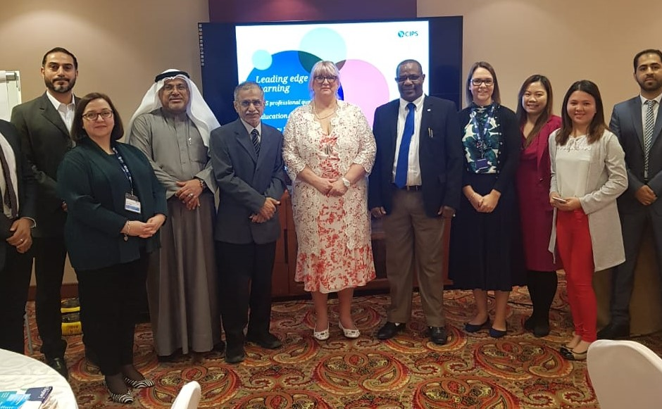
Joe (fifth from the right) after presenting to CIPS lecturers from across the Middle East and North Africa in Manama, Bahrain, 15 March 2019.
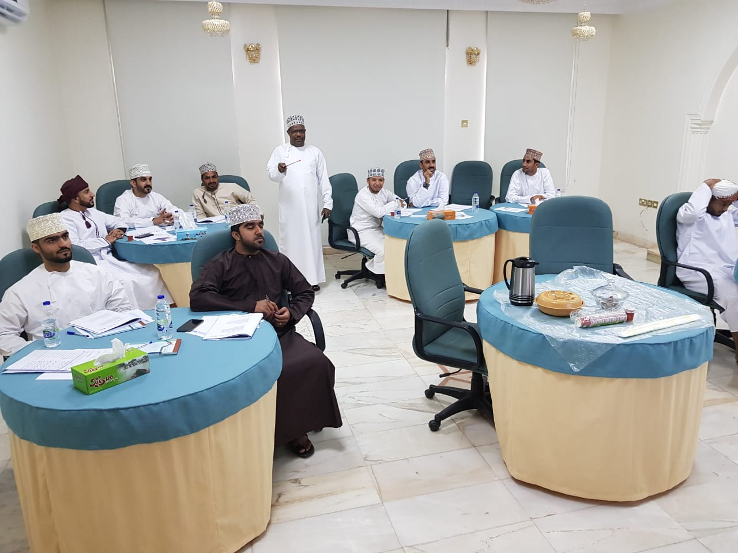
Joe delivering a Contract Drafting workshop to contracting and tender staff from Oman's Ministry of Defence — Royal Navy of Oman, 14 July 2019.
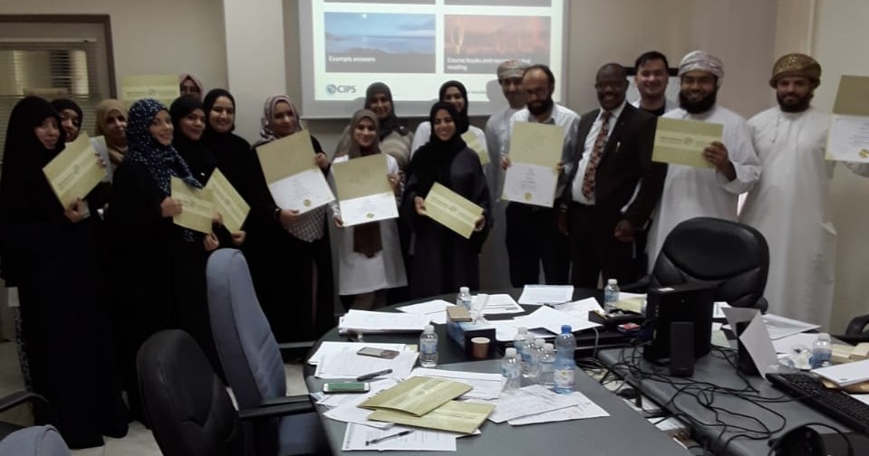
Joe (fourth from the right) presenting certificates to medical officers, doctors, nurses, and procurement, stores, transport, and logistics officers from the Directorate of National Medical Supplies, Muscat, Sultanate of Oman.
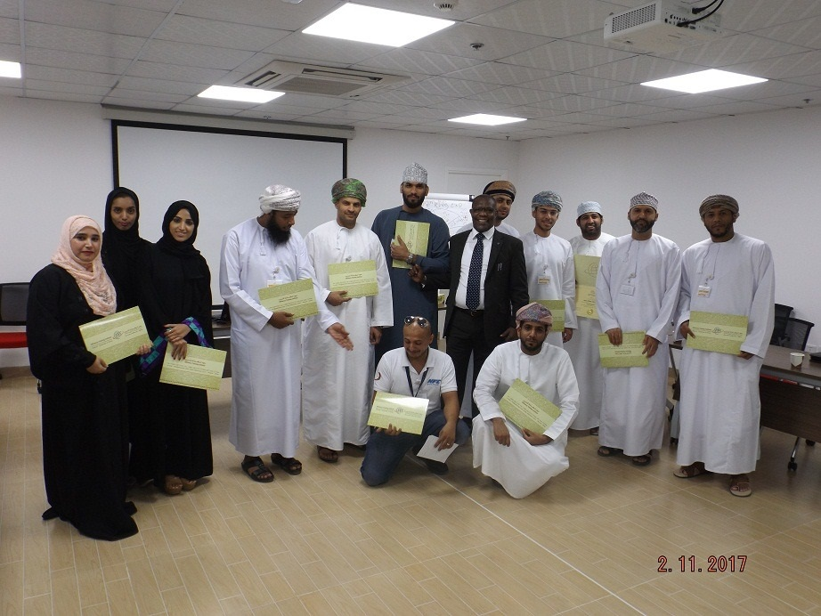
Joe (centre) presenting Category Management training certificates to staff of ASYAD S.A.O.C., under Oman's Ministry of Transport — the body providing integrated land, sea, and air logistics across the Sultanate, including ports, free zones, and shipping.
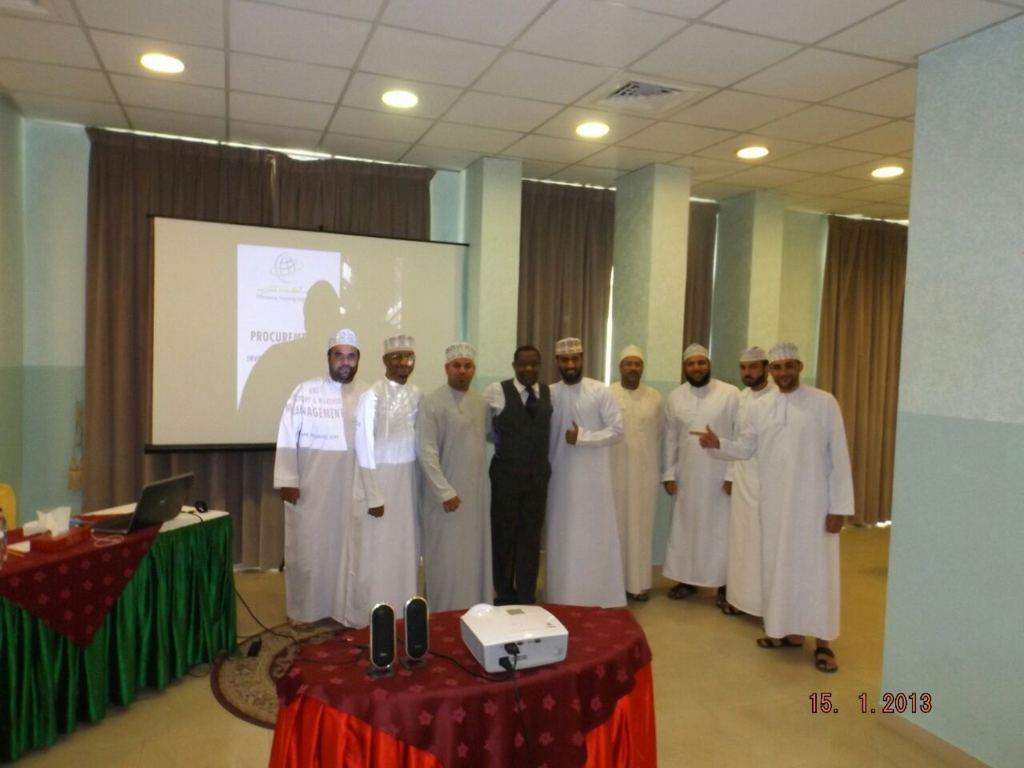
Joe (fourth from the left) is training and presenting certificates for an Inventory and Warehouse Management course delivered to staff of Oman's Posts and Telecommunications organization.

